SANFORD HEALTH OF NORTHERN MINNESOTA
SPECIMEN COLLECTION MANUAL
Blood specimens:
Lab staff will utilize the Procedure Catalog within the LIS.
Non-Lab staff can call the laboratory for specimen requirements.
Test | Ordering Information | Container(s) | Instructions
Aerobic culture | MICR0003  CULTURE BACTERIAL, OTHER  MICR0043 CULTURE, GENITAL GROUP B STREPTOCOCCUS SCREEN  MICR0005 CULTURE, SCREEN FOR SINGLE PATHOGEN |  | Other sterile containers not containing additives or preservatives are also acceptable  Send specimen at room temperature
  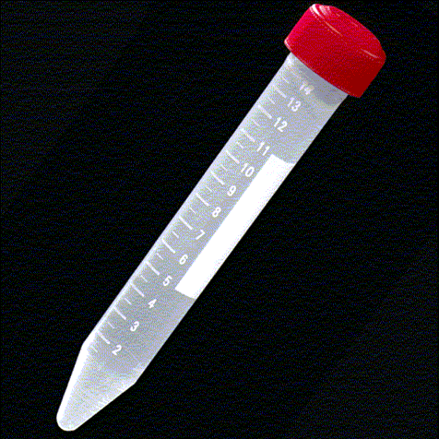
  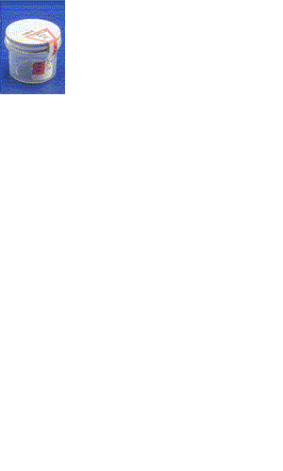
  Eswab
  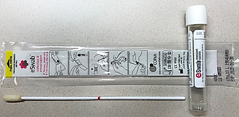
  Sterile Container
Acid Fast Bacillus Culture (Mycobacterium), specimens other than blood or bone marrow | MICR0019  CULTURE, ACID FAST BACILLUS WITH STAIN | 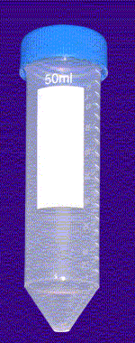 | Other sterile containers not containing additives or preservatives are also acceptable  Send specimen at room temperature
  Sterile Containers
Aerobic culture with gram stain | MICR0032  CULTURE BACTERIAL, OTHER W GS |  | Other sterile containers not containing additives or preservatives are also acceptable  Send specimen at room temperature
  Eswab
  Sterile Container

Test | Ordering Information | Container(s) | Instructions
Anaerobic culture | MICR0009  CULTURE BACTERIAL, ANAEROBE | Eswab | Send specimen at room temperature
Blood Culture | BLOD0990  CULTURE, BLOOD  Either a set of aerobic and anaerobic blood culture bottles or a pediatric bottle  Volume: 8-10 mL (aerobic/anaerobic) and 0.5-3 ml in pediatric bottle |  | Aerobic and anaerobic bottles should be drawn in a set, or the aerobic bottle can be drawn alone  Pediatric bottles may be drawn in place of aerobic and anaerobic bottles when necessary  Send specimen at room temperature
  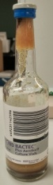
  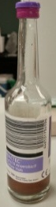
  Aerobic (blue)/Anaerobic (purple)
  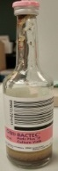
  Pediatric (pink)
Blood Culture for Acid Fast Bacillus (Mycobacterium) | BLOD1118  CULTURE, ACID FAST BAC, BLD  10 mL (5 mL min) whole blood |  | Send in original tube within 48 hours of collection  Lithium heparin or Isolator tube also are acceptable  Send at room temperature
  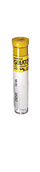
  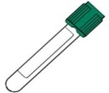
  Heparin tube (4mLX2)
  Pediatric Isolator Tube (1.5mL)
Blood Culture for Fungus | BLOD1097  FUNGAL CULTURE, BLOOD | Isolator Tube (10mL)  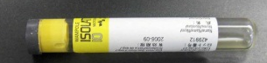  Pediatric Isolator Tube (1.5mL) | Send specimen at room temperature

Test | Ordering Information | Container(s) | Instructions
Cerebrospinal Fluid Culture: Aerobic Culture  Acid Fast Culture  Fungus Culture | MICR0003  CULTURE BACTERIAL, OTHER  MICR0019  CULTURE, ACID FAST BACILLUS WITH STAIN  MICR0023  CULTURE FUNGAL, OTHER | CSF Sterile Container  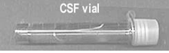 | Cerebrospinal fluid in a sterile container  Send specimen at room temperature
Cryptosporidium/Giardia Rapid Assay | NBLD0418  Cryptosporidium/Giardia Rapid Assay | Collect fresh stool specimen and place immediately in 10% formalin.  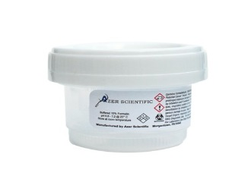 | Send specimen at room temp
Chlamydia Trachomatis and Neisseria Gonorrhoeae  Chlamydia Trachomatis only  Neisseria Gonorrhoeae only | NBLD0267  CHLAMYDIA & N. GONORRHEA  NBLD0294  CHLAMYDIA NUCLEIC ACID SCREEN  NBLD0295  GONORRHEA NUCLEIC ACID SCREEN | Cobas PCR Urine Collection  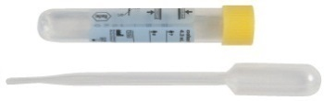  Cobas PCR Female Swab  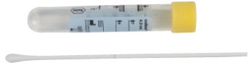  Cervical Specimens in PreservCyt  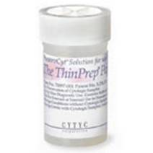 | Male and Female urine  Female Endocervical or vaginal swabs  Cervical Specimens in PreservCyt
Clostridium Difficile - stool | NBLD0538 C DIFFICILE TOXIN B NUCLEIC ACID DETECTION |  | 1.0 mL of loose or unformed stool  Formed stool will be rejected for testing
  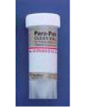
  Empty Vial Stool Transport
  Or sterile container
Test | Ordering Information | Container(s) | Instructions
Fungus Culture  Nails, Hair, Skin-  Dermatophytes  All Other Sources | MICR0022  CULT FUNGAL, SKIN, HAIR, NAILS  MICR0023  CULTURE FUNGAL, OTHER | 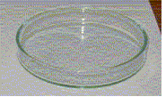 | Other sterile containers not containing additives or preservatives are also acceptable  Send specimen at room temperature
  Sterile Containers
Fungus Culture with KOH  Nails, Hair, Skin-  Dermatophytes  All Other Sources | MICR0022  CULT FUNGAL, SKIN, HAIR, NAILS and NBLD0300 KOH PREP, SKIN HAIR OR NAILS  MICR0023 CULTURE FUNGAL, OTHER and NBLD0299 KOH, BAL, BR WASH OR VAG |  | Other sterile containers not containing additives or preservatives are also acceptable  Send specimen at room temperature
  Sterile Containers
Group B Streptococcus NAD Prenatal Screen | NBLD5000  GROUP B STREP NAD  NBLD5011 GROUP B STREP NAD, PENICILLIN ALLERGY, REFLEX TO SUSCEPTIBILITY  Vaginal/Rectal swab | Double etched swabs  With Green NAD sticker  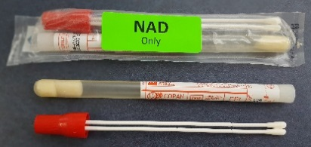 | If patient has presented for delivery without prenatal testing, send to the laboratory urgently

Test | Ordering Information | Container(s) | Instructions
Identification or susceptibility testing of an aerobic organism sent from another laboratory  Identification of susceptibility testing of an anaerobic organism sent from another laboratory | LABS0218  LAB ONLY - SENS/SUSCEP STUDY  LABS0215  LAB ONLY - CULT, ORGANISM ID  LABS0217  LAB ONLY - ORGANISM ID ANAEROBE  Send pure isolate on appropriate media | Blood Agar Plate  ANA Blood Agar Plate | Send specimen at room temperature
Influenza A and B, NAD | NBLD0381 INFLUENZA A and B NUCLEIC ACID DETECTION  NBLD0375 INFLUENZA A and B and RSV NUCLEIC ACID DETECTION | 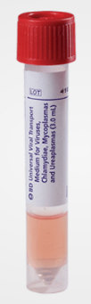  Nasopharyngeal swab specimens 3.0 mL BD VTM (Universal Transport media) with flocked swab, Lawson# 6260951 | Send specimen at room temperature
KOH for Fungal Elements | NBLD0300  KOH PREP, SKIN HAIR OR NAILS  NBLD0299  KOH, BAL, BR WASH OR VAG |  | Other sterile containers not containing additives or preservatives are also acceptable  Send specimen at room temperature
  Sterile Containers
MRSA Nasal Screen | NBLD0394  MRSA BY NUCLEIC ACID DETECTION  Anterior nares swab specimen
  Double Etched Swabs with Green NAD sticker

Test | Ordering Information | Container(s) | Instructions
Mycobacterium Tuberculosis Complex and Rifampin Resistance, NAD | NBLD0535  Mycobacterium Tuberculosis Complex and Rifampin Resistance | Sterile Containers | Other sterile containers not containing additives or preservatives are also acceptable  Send specimen at room temperature
Nasal Culture | MICR0001  CULTURE BACTERIAL, RESPIRATORY |  | Send specimen at room temperature
  Eswab
Nasopharyngeal Culture | MICR0001  CULTURE BACTERIAL, RESPIRATORY | SWAB COLLT FLEX MINITIP 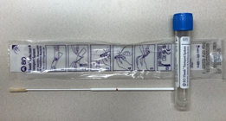 | Send specimen at room temperature
Ova and Parasite Exam | MICR0011  OVA AND PARASITE COMP EXAM  Stool specimen in Para-Pak Collection Kit |  | Mix stool in solution until it reaches the red line within 20 minutes of collection  Send specimen at room temperature
  Para-Pak Containers
  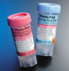
  Obtained from the Laboratory
Parasite Identification | MICR0035  PARASITE IDENTIFICATION WORM  MICR0034  PARASITE IDENTIFICATION BUG  BOLB5003  SCABIES-IN CLINIC | Sterile Containers | Deliver to the laboratory as soon as possible. Laboratory staff will determine preservative is needed.

Test | Ordering Information | Container(s) | Instructions
Pertussis | NBLD0274  Bordetella Pertussis/  Parapertussis Nucleic Acid Detection | SWAB COLLT FLEX MINITIP | Deliver to the laboratory as soon as possible. Sample is stable refrigerated at 24hrs and 7 days frozen.
Pinworm | NBLD0220  PINWORM EXAM | 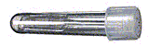  Pinworm Paddle | Send specimen at room temperature
RSV, NAD | NBLD0519 RSV NUCLEIC ACID DETECTION  NBLD0375 INFLUENZA A and B and RSV NUCLEIC ACID DETECTION | Nasopharyngeal swab specimens 3.0 mL BD VTM (Universal Transport media) with flocked swab, Lawson# 6260951 | Send specimen at room temperature
Sputum Culture | MICR0031  CULTURE BACTERIAL, RESP W GS  Sputum specimen in a sterile culture | Sterile Containers | Other sterile containers not containing additives or preservatives are also acceptable  Send specimen at room temperature within 2 hours, or refrigerate if transport >2 hours
Sterile Body Fluid Culture: Pleural, Pericardial, Synovial, Peritoneal, Ascites, Joint | Order appropriate test/s per Physician's orders |  | Other sterile containers not containing additives or preservatives are also acceptable  Send specimen at room temperature
  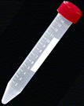
  Sterile Containers

Test | Ordering Information | Container(s) | Instructions
Stool, Basic Enteric Pathogen Panel, NAD | NBLD0516  Basic Enteric Pathogen Panel, NAD  Stool specimen in Enteric Plus Container | Enteric Plus  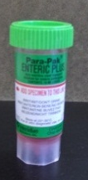 | Specimens must be placed in Enteric Plus Container or delivered to the Microbiology Lab within 2 hours  Mix stool in media until it reaches the red fill line  Send specimen at room temperature
Throat Culture for Group A Streptococcus | MICR0001  CULTURE BACTERIAL, RESPIRATORY  Screen for Group A Strep and Acranobacterium | Eswab | Send specimen at room temperature
Throat screen for Group A Streptococcus | NBLD0533  Group A Streptococcus by NAT  * Also used for confirmation testing of serologic methods. | Eswab  *select sites may use the purple cap Eswab 480CFA | Send specimen at room temperature
Tissue Culture | Order appropriate tests codes per Physican orders:  MICR0032  CULTURE BACTERIAL, OTHER W GS  MICR0009  CULTURE BACTERIAL, ANAEROBE | Sterile Container | Other sterile containers not containing additives or preservatives are also acceptable  Send specimen at room temperature
Trichomonas, NAD | NBLD0545 TRICHOMONAS VAGINALIS BY NUCLEIC ACID DETECTION | Xpert Vagina/Endocervical Swab Collection Kit (pink)  Lawson 6272690  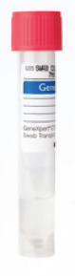  Xpert Urine Specimen Collection Kit (yellow)  Lawson 6272691 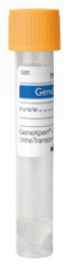 | Contact the laboratory if collection instructions are needed.  Note for Urine specimen: Direct patient to provide first-catch urine (20-50mL) into a urine collection cup.  The patient should not have urinated for at least 1 hour prior. Patient should not cleanse the genital area prior to collecting specimen.
Test | Ordering Information | Container(s) | Instructions
Urine Culture | MICR0013 CULTURE BACTERIAL, URINE |  | Send specimen at room temperature
  Grey Top Urine Culture Tube or sterile urine container
  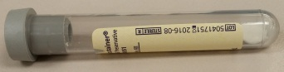
Wet Prep for Trichomonas, Yeast and Clue Cells | NBLD0305 WET PREP | Eswab | Send specimen at room temperature

